Session Plan
Teacher: Scott Bull
Date: Week 1 Place: Lynbrook Secondary. Age/Year Level: Year 8 No. of Learners: 15-20
Topic: Tactics and applied skills Duration: 70 minutes
Learner Objectives:
- To gain an awareness of the use of space in invasion type sports.
- Improve on team techniques and to integrate this into the game.
- Fundamentals of tactical awareness (positioning on field, reading plays, utilisation of set skills in sequence as per game conditions)
- Effectively utilise complex movement patterns at an associate level

Teacher Objectives:
- Provide clear instruction and keep the purpose of the lesson clear. Continually emphasise the focus of the lesson to students.
- Provide clear demonstrations for defensive skill techniques. Use words or phrases that highlight the important part on which the demonstration is focusing.
- Staying on time with each task so all content can be covered.
Links to VELS (domain, dimension, level)
Domain: Physical, personal and social learning.
Dimension: Health and physical education.
Level: Level 5 focuses for this coaching session, the main rationale behind this lesson is for the students to use abstract concepts, act in a non-participatory role and develop their abilities to plan and strategize.

Evaluation of Learner Objectives:

Time | Preparation/Resources | Lesson Content | Main Focus  linked clearly to objectives | Comments
10 mins | 20 Cones  3 Bibs  2 Handballs | Students are to partner up (so one with bib vs. plain) with the main aim to get the ball to their player on the opposite side. However the defence must put pressure on the attack to force a turnover.  Rules:  This game is the base invasion game setting; attacking and defending rules are the same; however a player successfully gains possession and traps the ball, the defender steps aside and the goal is replaced by an external player. All passing is to be with the lower body and players must stay in their own zones  Activity layout  Emphasis must be placed on the transferability of these skills to other invasion type sports | Questions such as:  Why and when should you short/long pass?  How can you predict your opponent’s movements?
+10 mins | 2 Goals  10 Bibs  4 Handballs | Short pass into shot on goal (One two-step)  This activity focuses on agility and faster gameplay, trying to use fast breaks to break the defensive formation (also exposes the defence to counter measures in an event of a fast break towards the goal if you include two defenders as well the goal keeper)  The aim of this is the emphasise the need for controlling space over raw skill, as this can make you a far more efficient sports person (also it requires less exertion, so the activity is easier)  Activity layout  Again the educator is to emphasise that these ideas are incorporated in other invasion games (like netball/basketball) | Incorporating the short pass with a one-two step into a shot at the goal  Main Questions:  Which side are we attacking to?  How to we maximise our efforts on attack/defence?  How does the role of the goalkeeper change as offence and defence?
+10mins | 2 goals  10 Bibs  2 Handballs | Handball Mini-game  Incorporating the prior skill sessions, students are to apply their new understandings of movement in invasion sports in a small sided game of handball. The main aim of this is to contextualise the learning with has occurred, potentially influencing their growth as a producer-consumer of physical activity.  Activity set up  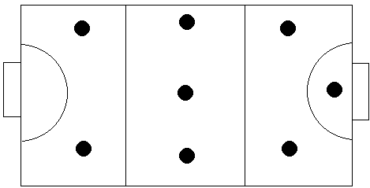 | Educator is to monitor progress and use teachable moments to highlight key concepts or patterns which are being exhibited during the game session
Conclusion | None | Debrief and discuss  What can we learn from this  What have I developed from this  What do I need to develop | The main idea is to pick out key themes and ideas into actively thinking about their own participation in invasion games.

